**TABLE OF CONTENT**

**Introduction**

* 1. Purpose
  2. Document Conventions
  3. Intended Audience
  4. Project Scope

1. **Overall Description**
   1. Product Features
   2. User Classes and Characteristics
   3. Operating Environment
2. **External Interfaces Requirements**
   1. User Interfaces
   2. Communication Interfaces

**INTRODUCTION**

**Purpose**

The H.E.A.R.T web application is developed with the ideology of advertising an online School Institute to the public allowing them to view our campus, enrol in various courses and for necessary Authority to manage the application.

**Document Convention**

This document uses the following conventions

|  |  |
| --- | --- |
| DATABASE |  |
| MYSQL |  |
|  |  |

**Intended Audience**

The H.E.A.R.T website targets young adults and adults who seeks to further improve or learn skills which are demanded by the working economy and those who aspire to venture solo.

**Project Scope**

The H.E.A.R.T site is a website which allows users to login and register for a H.E.A.R.T course and provide numerous features for admin to manage the flow of the application .

**Overall Description**

The site consist of only two user types:

* **ADMIN**
* **USERS**
* **GUESTS**

The Admin role manages the Application request of the users, the accessibility of the users and control which courses to add or remove.

The Users are allowed to Apply for courses and Update their personal information.

**LOGIN AND REGISTER**

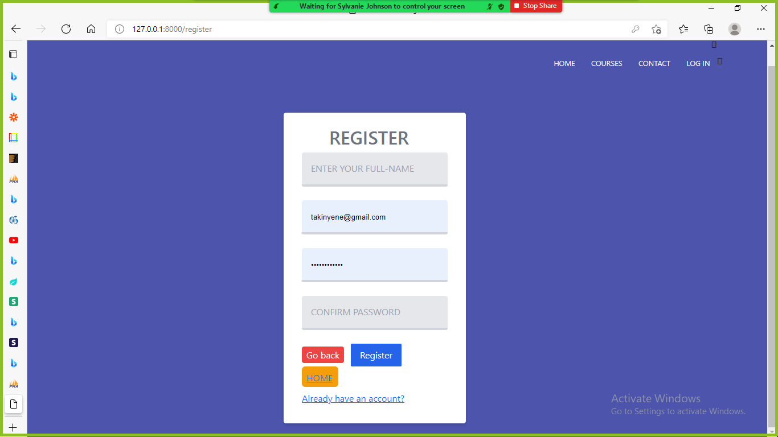

The Registration form captures users basic information to allow them to access the site Application form, so users will not be able to apply unless they have registered with H.E.A.R.T. This also adds security to user’s information.

The HOME button will take user to the Home Page

The Go back button will take users to the previous page

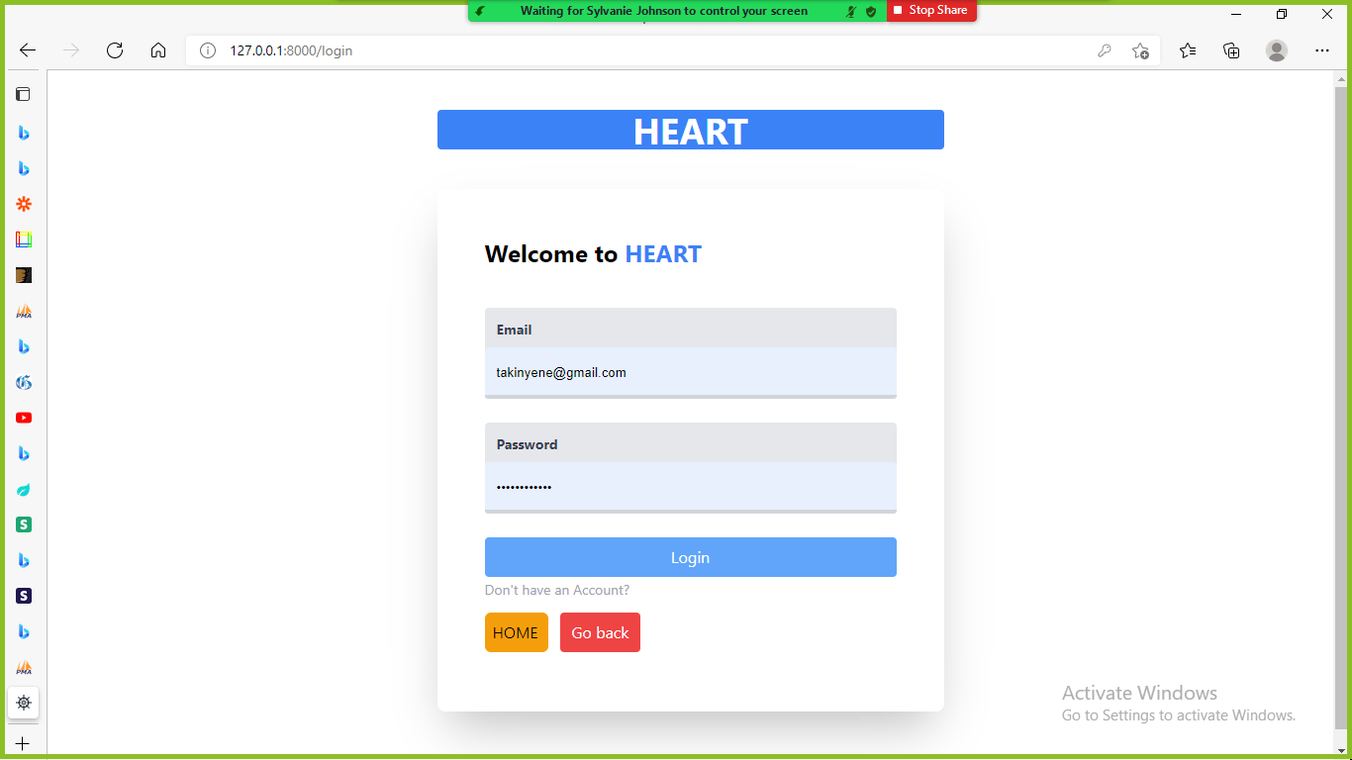

Once a user has registered they will be redirected to the login page where they input their information and Login.

The HOME button will take user to the Home Page

The Go back button will take users to the previous page

**User classes and Characteristics**

CHARACTERISTICS OF ADMIN ACCOUNT:

* Be able to Add and Delete Courses
* Be able to deactivate Users Account
* Be able to view Applicants Information
* Accept or Reject Applicants

CHARACTERISTICS OF USER ACCOUNT:

* Be able to make comments
* Apply for courses
* Adjust their Information

**Operating Environment**

Front-End and Back-End Interfaces

* Vscode text editor (recommended by Mr.Thompson)
* Mysql Database
* Laravel Framework
* Tailwindcss styling
* Xampp

**INTERFACE REQUIREMENTS**

**User Interface**

Home page for Guests

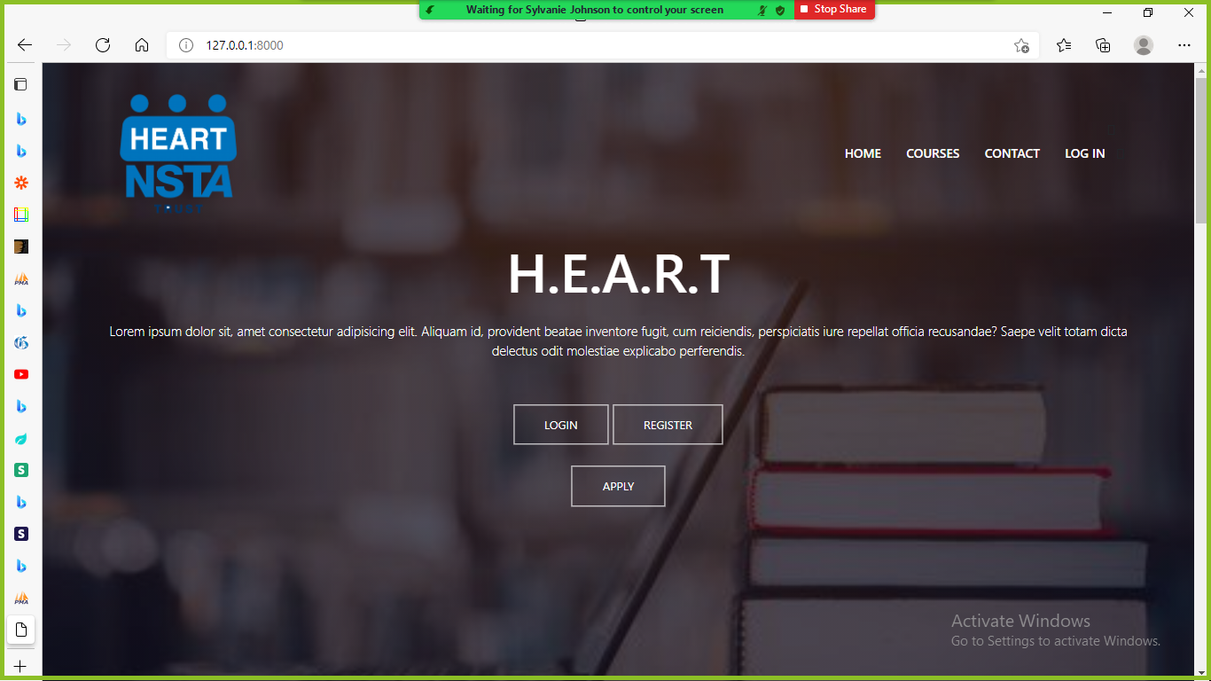

Navigation bar

1. Home
   * 1. Which gives the User the option to register or login
     2. View the comments
     3. Show courses
     4. About us
     5. Contact Information

1. Courses

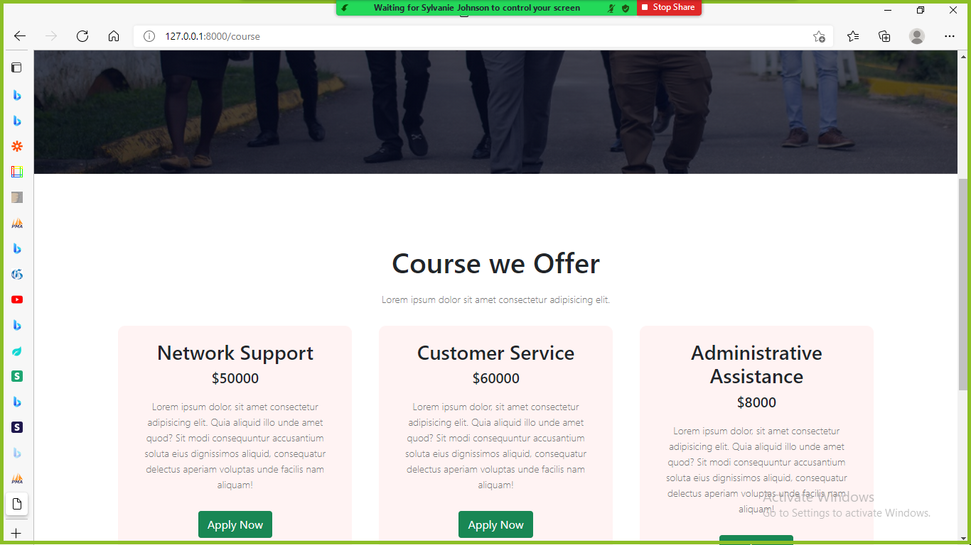

* 1. This page will display all the available courses and the prices
  2. Guests will not be able to apply for course until they have registered

1. Contact
   1. This will navigate open a contact form on the page or to navigate the contact section on the home.
2. Login
   1. This will navigate to the login page

HOME PAGE FOR USERS

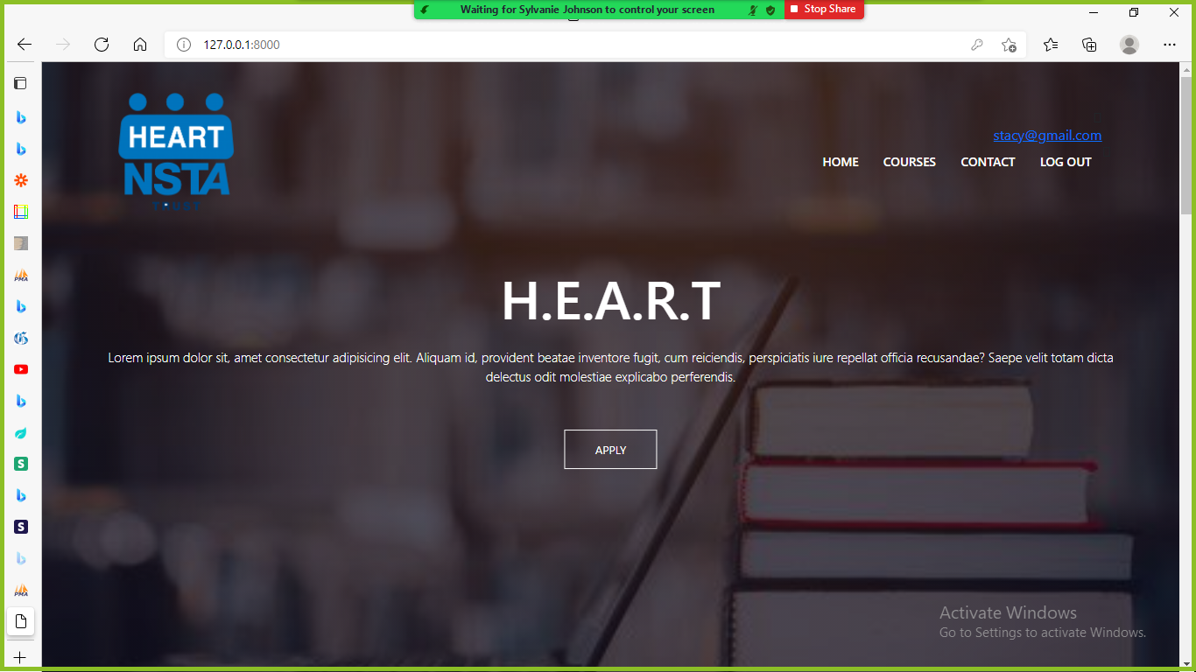

1. Home
2. Consist of the Apply button which will take you to the courses page
3. Courses
4. Comment section
5. About us
6. Courses
7. This will navigate to Courses page
8. When a user selects a course to apply for it will take them to the application form

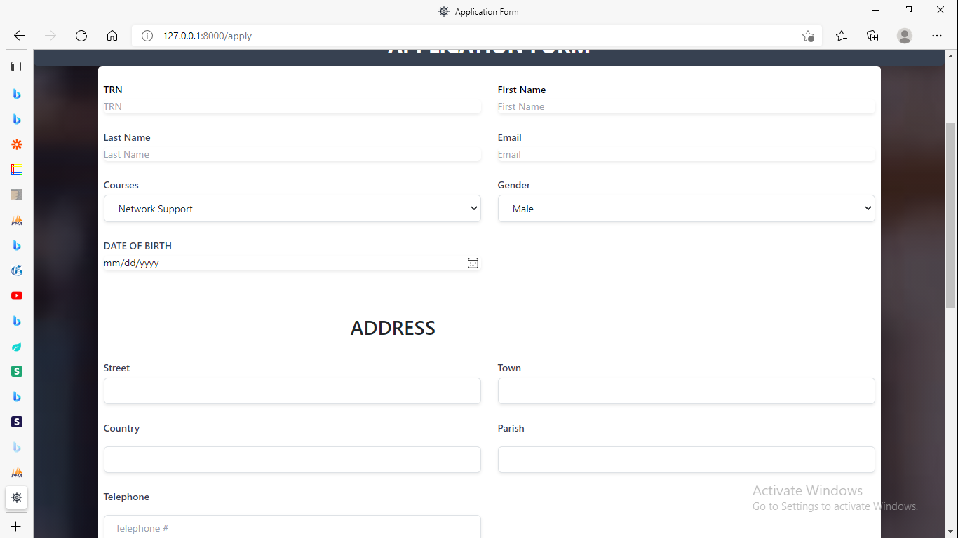

1. Email Address
2. When users click Email Address it will take them to the update page
3. This shows personal information and Update form

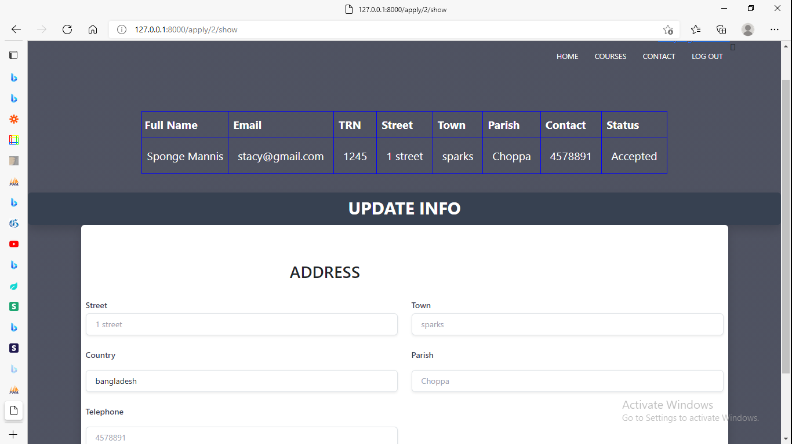

1. Contact
   1. This will open a contact form on the page or to navigate the contact section on the home.
2. Logout
3. This will Logout current user and redirect to Login

Admin Homepage

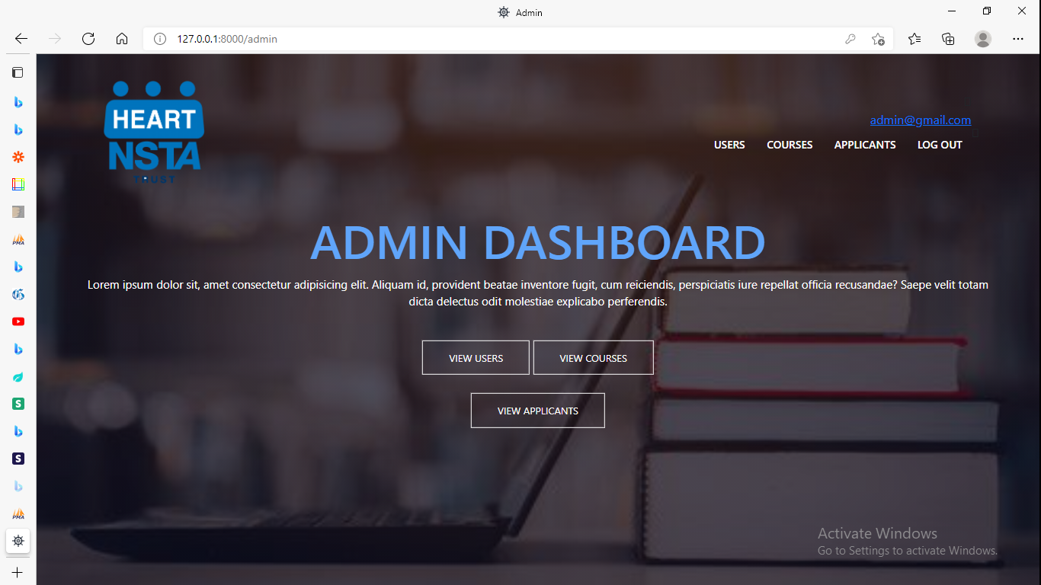

1. Users
2. This will navigate to users page which display all registered users.

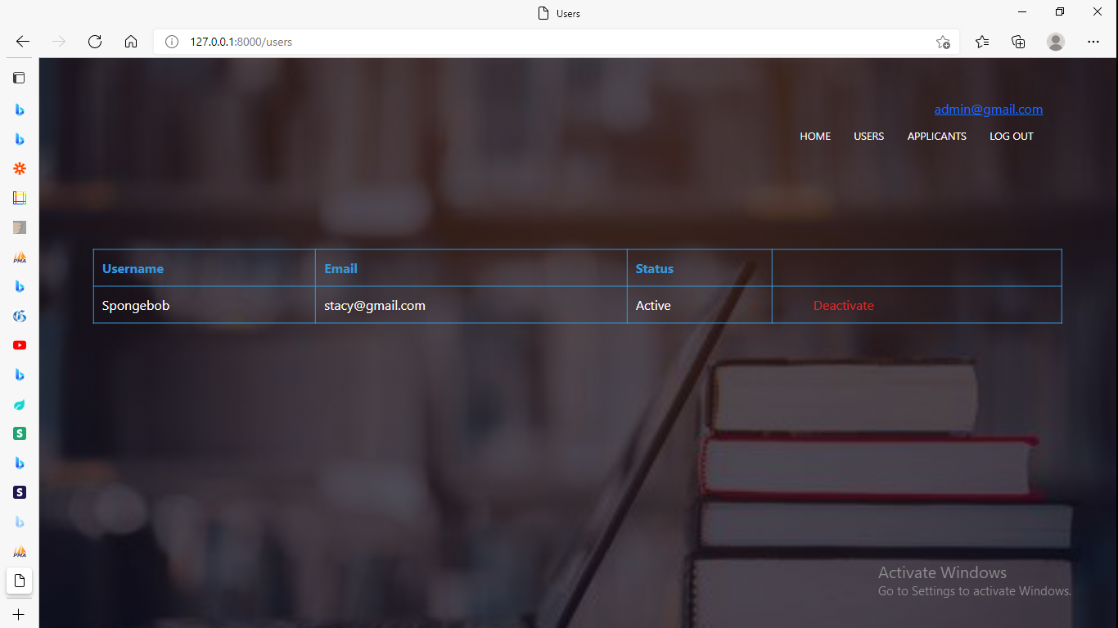

1. Admin can Deactivate users account

1. Courses
2. This page displays all courses
3. Can add or remove courses
4. Applicants
5. This will show all users who have applied
6. The view applicant button will navigate to the Personal info of the Applicant.

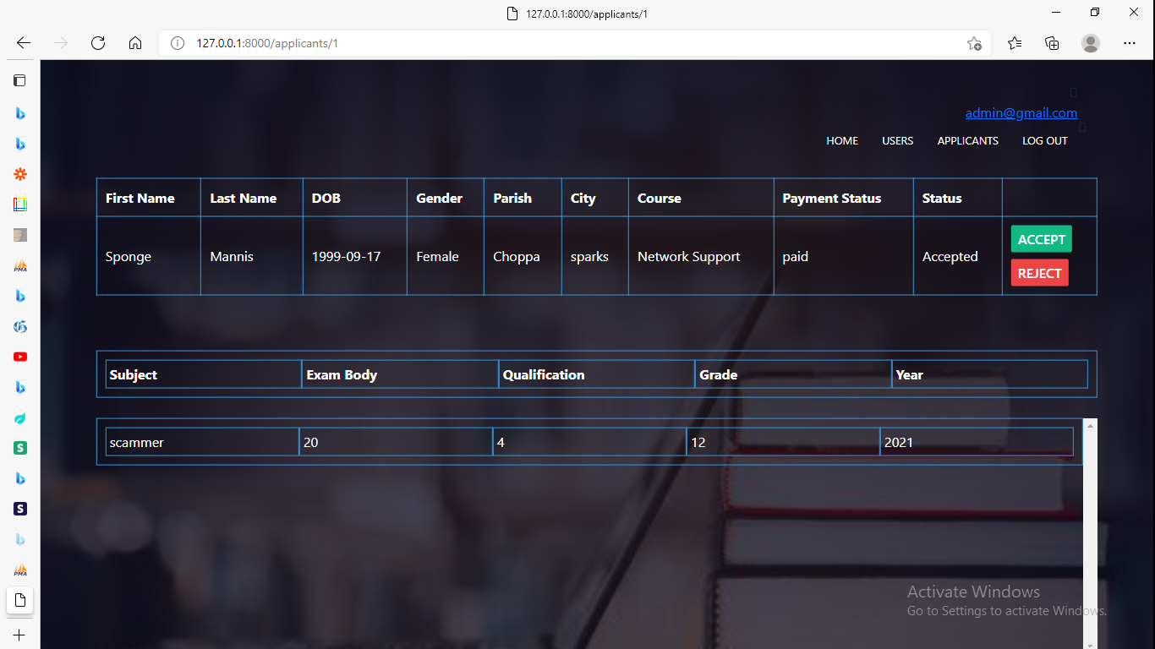

1. Logout
2. This will log out the current user